**TASK 2: SQL**

**Table name: Customer**

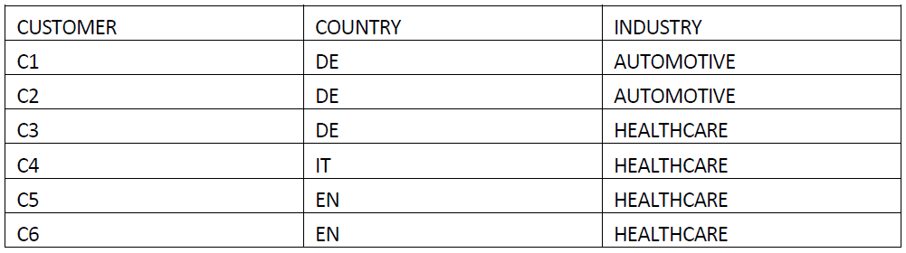

**Table name: Sales**

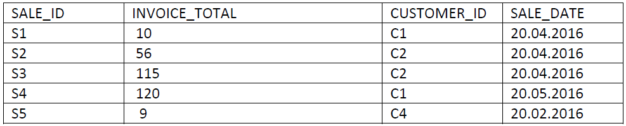

1. Write a SQL query that displays the number of customers per industry.

WITH BASE AS (

SELECT INDUSTRY, COUNT(DISTINCT CUSTOMER) AS NUMBER_OF_CUSTOMERS

FROM Customer

GROUP BY 1

)

SELECT *

FROM BASE

1. Write a SQL query that displays the average invoice total per industry.

WITH BASE AS (

SELECT a.INDUSTRY, COALESCE(AVG(b.INVOICE_TOTAL),0) AS AVERAGE_INVOICE_TOTAL

FROM Customer a

LEFT JOIN Sales b ON b.CUSTOMER_ID = a.CUSTOMER

GROUP BY 1

)

SELECT *

FROM BASE

c) Write a SQL query that displays what each customer spent per month, if that value is

bigger than 100.

WITH BASE AS (

SELECT DATE_TRUNC('month',b.SALE_DATE) AS SALE_DATE_MONTH,

a.CUSTOMER,

SUM(b.INVOICE_TOTAL) AS SUM_INVOICE_TOTAL

FROM Customer a

LEFT JOIN Sales b ON b.CUSTOMER_ID = a.CUSTOMER

GROUP BY 1,2

HAVING SUM(b.INVOICE_TOTAL) > 100

)

SELECT *

FROM BASE

d) Write a SQL query that ranks clients within Industry based on respective sales total.

WITH BASE AS (

SELECT a.INDUSTRY,

a.CUSTOMER,

SUM(b.INVOICE_TOTAL) AS SUM_INVOICE_TOTAL

FROM Customer a

LEFT JOIN Sales b ON b.CUSTOMER_ID = a.CUSTOMER

GROUP BY 1,2

ORDER BY 1,3 desc

)

SELECT a.*,

RANK() OVER (PARTITION BY a.INDUSTRY ORDER BY a.SUM_INVOICE_TOTAL DESC) AS Ranking

FROM BASE a